Met Museum Assignment #1

This assignment consists of 4 separate essay questions on artworks you will find and examine in different galleries at the Met Museum. It is highly recommended that you read over the entire assignment before getting started. You should complete all the assigned class readings and videos before your Met visit, including on Post-Impressionism, Art Nouveau, Symbolism and Rodin.

For each essay question, I have given you instructions starting below on where and how to find the galleries for each question taking you through the galleries beginning with Symbolism, Art Nouveau, then Impressionism and Post-Impressionism.

Formatting Guidelines: Typed, 12-point font, double-spaced. The assignment is due in three weeks on October 5 / Class 5 in class. I do not accept any late papers or papers by email unless you have made prior arrangements with me.

Please do not insert images into your final typed assignment. Instead, refer to artworks in your answers by the artist’s last name and the artwork’s title. (No other information, such as size, materials or Met identification information is needed, just artist’s last name and artwork’s title, which you will find on a label next to the artwork.)

About Metropolitan Museum of Art: www.metmuseum.org
The Met is on Fifth Avenue at 82nd Street. You can take the 4, 5, or 6 trains to 86th Street, where you will exit the station at Lexington Avenue and walk a few blocks west and four blocks south (10 minute walk from subway station to museum).

Cost: Remember, the Met Museum is ‘pay-what-you-wish’, meaning you have to pay something, but the amount is entirely up to you. I usually pay between $1-$5.

Directions inside the museum to the galleries for questions 1-3:
Get your ticket. Go up the main staircase. At the top of the stairs, go left and walk down the drawings and prints corridor gallery until you enter gallery 800, here you will see a bunch of Rodin sculptures, including preparatory small-scale studies for his larger sculptures.

Question #1: Symbolism
In this long hallway Gallery 800, see paintings by the Symbolists on the left side, including Pre-Raphaelite Edward Burne-Jones’ The Love Song; Gustave Moreau’s Oedipus and Sphinx; and Arnold Bocklin’s Island of the Dead. On the opposite end of the hallway gallery, see many small mural paintings by Puvis de Chavannes surrounding the studies by Rodin.
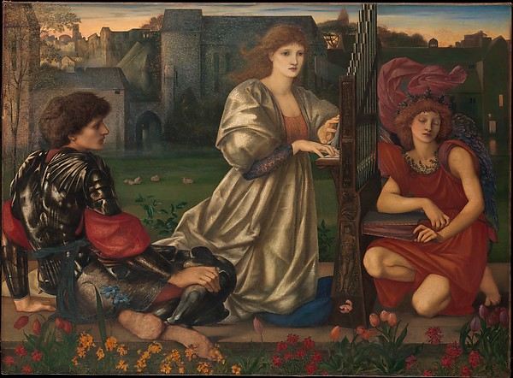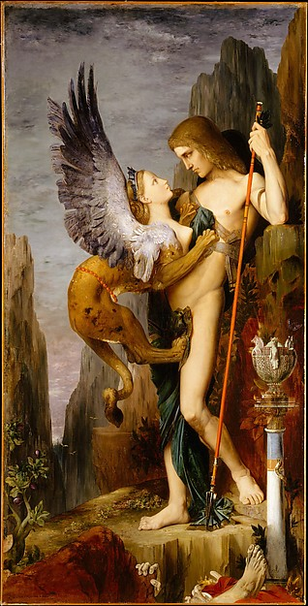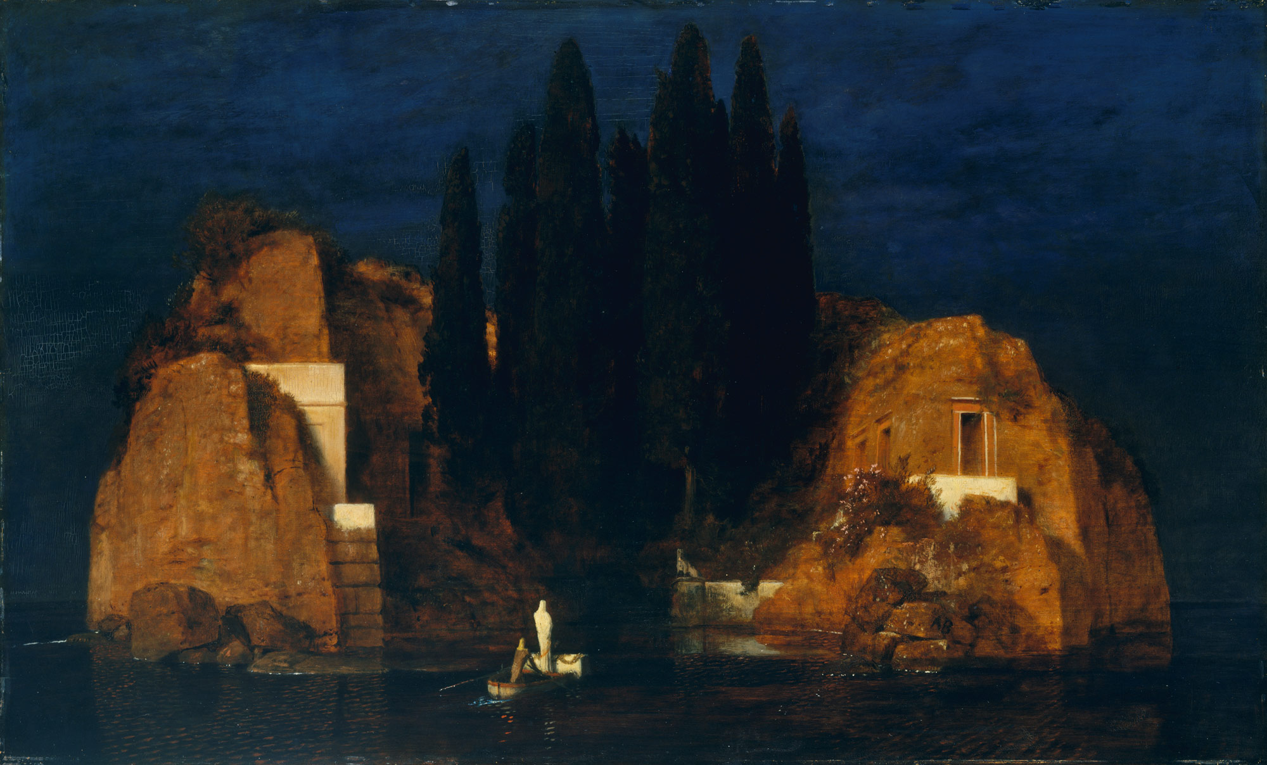
Review the Met’s essay about Symbolism, especially the second paragraph, which concludes: “In painting, Symbolism represents a synthesis of form and feeling, of reality and the artist’s inner subjectivity.”

- Question #1: Select one Symbolist painting from this gallery and explain in your own words what feeling, information or idea from the artist’s inner subjectivity or imagination is conveyed in the choice of subject matter. Also, explain how this information is made convincing by the artist’s use of accurate form and realistic details from the outside world. In short, explain both parts of this synthesis mentioned in the Met’s essay.

From here, go into the gallery on the left (801) and through it into the gallery that you will see immediately on your right as you enter 801. In here, you will find pastel drawings by Degas and Toulouse-Lautrec. Pastel crayon is a very difficult medium to draw with. See how Degas continued his experiments on bodily poses and positions with pastel drawings of women bathing and see how Toulouse-Lautrec admired and adapted Degas’ use of the sweeping and energetic line in his pastels.

Walk through these two small galleries to arrive at the only sculpture Degas exhibited in his lifetime, The Little 14-Year Old Dancer (Gallery 815). In the next gallery, you see all the studies he did for himself of horses, dancers and other figures with no intention of ever exhibiting them.
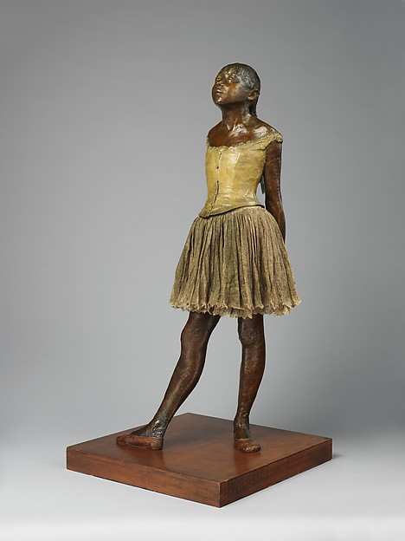

Question #2: Art Nouveau
In the next galley, see the “Wisteria” Dining Room, 1910-1914 (Gallery 813) – a dining room of furniture and objects with mural decorations all in the Art Nouveau style. Look at how the carpet and painted murals share the same color scheme and how each piece of furniture shares motifs from nature with curving lines and forms.
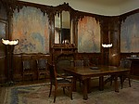
Review the assigned readings and videos about Art Nouveau.

- Question #2: Think about what we have discussed this semester about being modern and the forces of urbanism, technology, capitalism, the middle-class, and industrialization. Art Nouveau is a complex architecture and design style that developed as a reflection of and reaction to these forces. Consider the appearance and atmosphere of Art Nouveau objects in light of urban life, technology and capitalism. Why would this style develop at the end of the industrial revolution using forms and features like this? Explain in your own words why and how Art Nouveau can be seen as a response to modernity.

From here, walk into the gallery behind the dining room – Gallery 811 – where you will see early work by Eduard Manet, considered the father of modern art. Notice the deep earth tones, browns and blacks of these early studio paintings.
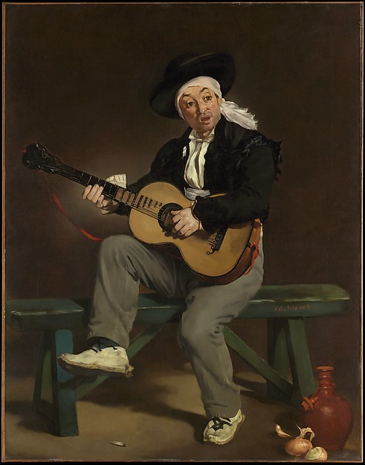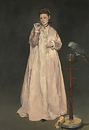
Walk through the middle of this gallery (with the Art Nouveau dining room behind you) into gallery 824 where you will see the Impressionists, including this Berthe Morisot painting and works by Auguste Renoir.
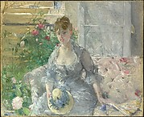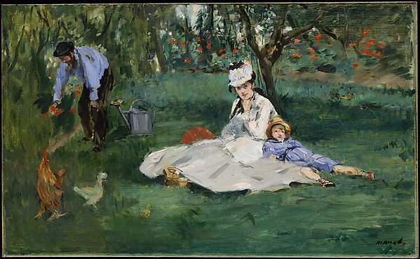
From here, go to the right through Gallery 821 into Gallery 818 heading towards the Monet below. Once Manet became friends with the Impressionists and they convinced him to begin painting outdoors, his palette changes dramatically. See two later paintings by Manet, including the one above that he painted of Monet and Monet’s family in their garden.

These two adjacent galleries (818 / 819) are a great chance to see early Monet next to his later work. Over his lifetime, he stayed with one idea – the effects of light, color and atmosphere on an object, but his style evolved dramatically over time, later favoring almost total-abstractions of the lily pond in his garden.
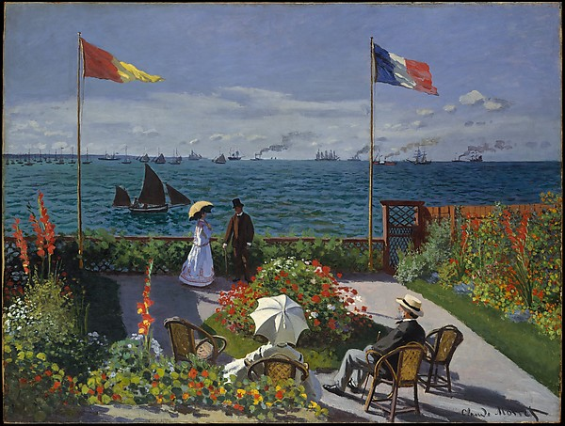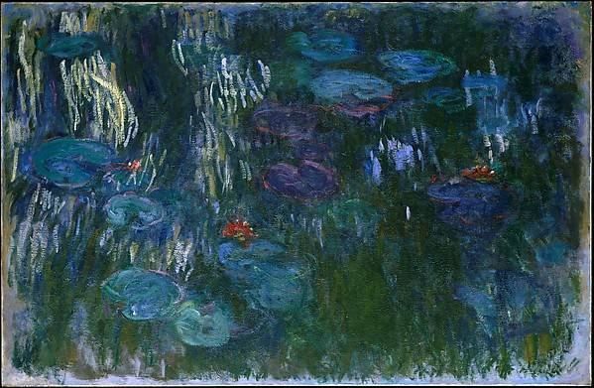

Question #3: Post-Impressionism
From Gallery 819, walk through the two galleries to the left and the two next to them (galleries 822, 825, 823, 826). You will recognize works by all of the 5 Post-Impressionists, including Seurat, Cezanne, Toulouse-Lautrec, Van Gogh and Gauguin. Walk around these galleries and examine works by the Post-Impressionists in preparation for Question #3.

Review the assigned readings and videos and your notes about the Post-Impressionists.
With Post-Impressionism, we see the beginning of abstraction take hold as artists begin to incorporate abstract color, specific types of lines and forms and spatial distortions to communicate their opinions, feelings or ideas in a subjective language, rather than with optically realistic or naturalistic images.

- Question #3: Select a painting by any of the Post-Impressionists except Seurat, who we will have used in class as our example. Explain in your own words: What is the artist’s overall goal or idea in selecting this subject matter and making this painting? What are they exploring and why is this important or interesting to them? How do they use the formal characteristics of color, line, form, spatial organization and/or the overall arrangement of forms on the canvas to convey their feelings or ideas to the viewer? Be specific.

Walking Directions to Question #4:
From these galleries, head into Gallery 830, where you will find artworks moving into the 20th Century by the Fauvists Henri Matisse and Andre Derain. You will also find works by Pablo Picasso in his transitional ‘rose period’ where he is beginning to simplify his figures into the geometric simplicity that will become Cubism.

From here, go right and into the corridor to find the bathrooms and the elevator. Take the elevator down to Floor 1 of the museum for Question #4.

When you come out of the elevator, look to your left where you should see a Classical sculpture from the backside. Head towards it. This is the European Sculpture Gallery 548.
Examine this Classical sculpture by Canova of the ancient Greek hero Perseus. This is a great example of Neoclassicism, the style that took its inspiration from the idealized ancient Greek example and was dominant in the beginning of the 19th Century before modernism.

Next, find Auguste Rodin’s The Burghers of Calais sculpture closer to the windows overlooking Central Park. At the end of this explanation, I have included a short summary of what this sculpture is about. Review it so you understand why these people depicted by Rodin were going to be memorialized with a sculpture.

All of the other work by the sculptors in this gallery is Neoclassical or Romanticist in style by artists who came before Rodin and worked in traditional, academic styles during the first part of the 19th Century.

Rodin was a modernist in his approach to form. He was commissioned to make this historical monument by the French government. It caused a great controversy for several reasons:
1. Rodin has eliminated the use of a pedestal in his presentation of these figures (notice how all the other sculptures are on pedestals in this gallery).
2. He has not idealized the figures and instead, he has treated their forms in abstract, stylized, and expressionistic ways. This was unheard of at the time, especially for a historical monument! It was expected that a historical monument would have idealized, Classical forms.

- Question #4: In two paragraphs, answer the following:
A. Explain the relationship between the figures in the sculpture and you as the viewer because of Rodin’s choice to eliminate the pedestal. What ideas or information about these historical figures is conveyed or communicated to the viewer with this choice in placement?

B. Rodin has used abstraction, stylization, and expressionistic elements to communicate the story of the Burghers’ ordeal as they may have experienced it.
Select two important elements of the sculpture’s appearance and explain what information Rodin communicates by using abstraction, stylization, and/or expressionism in these areas.
Consider, for example, what ideas are conveyed by the heaviness, verticality, and exaggeration of the drapery folds; the exaggerated size of the hands and feet; the varied arrangement of the figures in relation to one another; the texturized and bumpy surface appearance of areas of the figures; or other elements.
Do not just describe these things, but instead use their appearance as a way to explain what information is communicated using these representational choices.

(A note about color: The choice of bronze was a practical one with this sculpture intended for the outdoors. You are making an inaccurate assumption if you say that the dark color of this piece is symbolic or meaningful to the narrative. It’s not! Do not spend your answer discussing the color or choice of the bronze material. Instead, focus on what I am asking - what ideas or information is conveyed based on how Rodin has treated these forms.)

SUMMARY of the SUBJECT MATTER:

Auguste Rodin (French, born 1840 – died 1917), The Burghers of Calais, 1884–95, modeled or sculpted in clay, then cast in bronze (this version was cast in bronze in 1985)

The Burghers of Calais is probably the best and certainly the most successful of Rodin's public monuments. Rodin was commissioned by the city of Calais in northern France to commemorate an episode from the Hundred Years' War between England and France, which occurred during the Middle Ages in the 15th Century between 1337 until 1453.
Rodin closely followed the historical account of the French chronicler Jean Froissart stating that the six most prominent citizens of Calais, called Burghers at the time, were ordered to come out of their city, which had just been conquered by English forces, with their head and feet bare, ropes around their necks, and the keys for the gates to the city in their hands to surrender. They were being brought before the English king Edward III, who ordered the beheading of the six Burghers. In exchange for their sacrifice, he would spare the lives of the rest of the citizens of Calais. Rodin has portrayed them at the moment of departure from the city, led by Eustache de Saint-Pierre, the bearded man in the middle of the group. At his side, another Burgher, Jean d'Aire, carries a giant-sized key to the gates of the city. Their oversized feet are bare, many have ropes around their necks, and all are in various states of despair, expecting imminent death.
At this moment in the narrative, they are unaware that their lives will ultimately be saved by the intervention of the English queen Philippa. She was impressed by their sense of personal duty and sacrifice for the rest of the citizenry’s wellbeing so she successfully convinced her husband not to execute the Burghers.

This information is found on the Met’s website: http://www.metmuseum.org/toah/works-of-art/1989.407

