Met Museum Assignment #1

This assignment consists of 3 separate questions on artworks you will find and examine in different galleries at the Met Museum. It is highly recommended that you read over the entire assignment before getting started. You should complete all the assigned class readings and videos before your Met visit, including on Impressionism, Post-Impressionism, and Rodin.

I have mapped out the galleries in the museum you will be visiting and your route is explained below with the questions.

Formatting Guidelines: Typed, 12-point font, double-spaced. The assignment is due at the beginning of class 5 on February 28.
Please do not insert images into your final typed assignment. Instead, refer to artworks in your answers by the artist’s last name, the artwork’s title, and its date. (No other information, such as size, materials or Met identification information is needed, just artist’s last name, artwork’s title and date, which you will find on the label next to the artwork.)

About Metropolitan Museum of Art: www.metmuseum.org
The Met is on Fifth Avenue at 82nd Street. You can take the 4, 5, or 6 trains to 86th Street, where you will exit the station at Lexington Avenue and walk a few blocks west and four blocks south (10 minute walk from subway station to museum).

Cost: Remember, the Met Museum is ‘pay-what-you-wish’ for residents of New York City, meaning you have to pay something, but the amount is entirely up to you. I usually pay between $1-$5.

Directions from inside the museum to the galleries for questions 1-3:
Get your ticket. Go up the main staircase to the second floor. At the top of the stairs, go left and walk down the drawings and prints corridor gallery until you enter gallery 800, where you will see sculptures, including many preparatory small-scale studies by Rodin for his larger sculptures, and paintings by various Symbolists, including Pre-Raphaelite Edward Burne-Jones’ The Love Song; Gustave Moreau’s Oedipus and Sphinx; and Arnold Bocklin’s Island of the Dead.
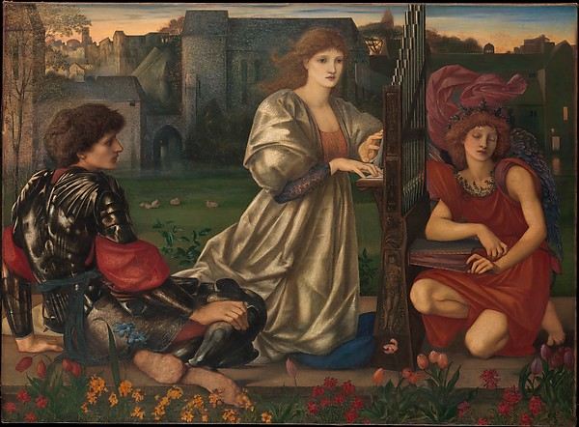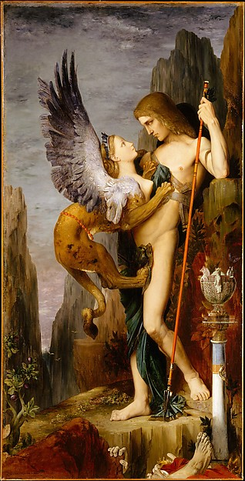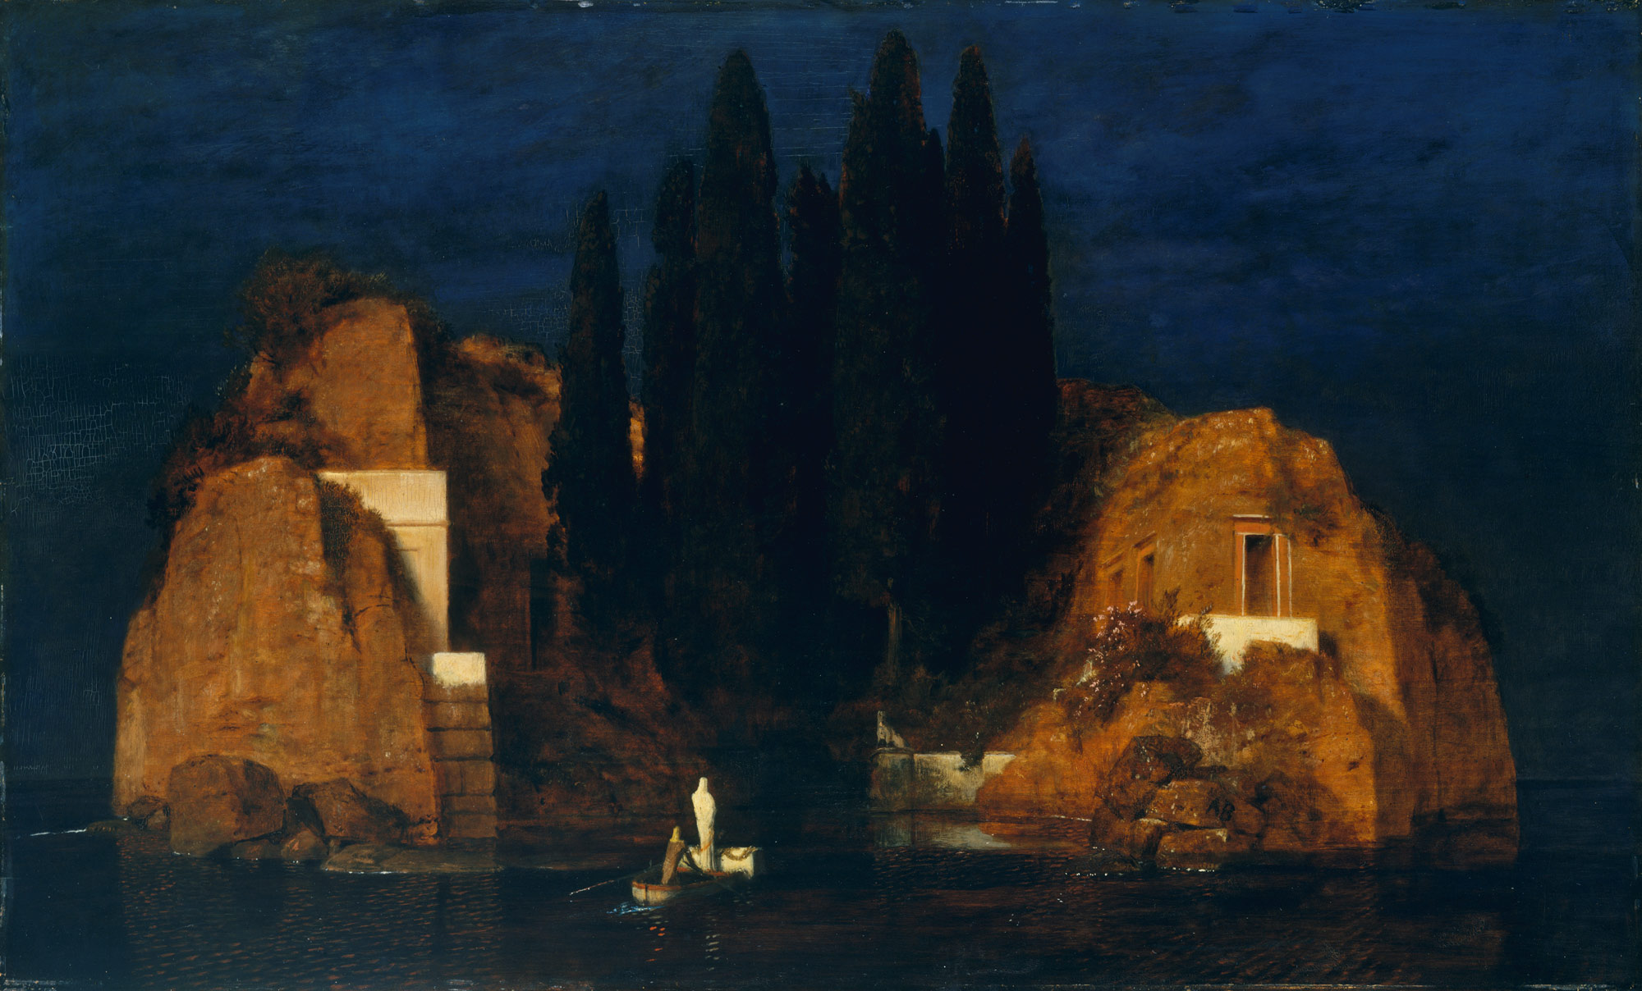

From here, go into the gallery on the far left (801) and through it into the gallery that you will see immediately on your right as you enter 801. In here, you will find pastel drawings by Degas and Toulouse-Lautrec. Pastel crayon is a very difficult medium to draw with. See how Degas continued his experiments on bodily poses and movement with pastel drawings of women bathing and see how Toulouse-Lautrec admired and adapted Degas’ use of the sweeping and energetic line in his pastels into his own work.

Walk through these two small galleries to arrive at the only sculpture Degas exhibited in his lifetime, The Little 14-Year Old Dancer (Gallery 815). You will also see many paintings with scenes from the ballet and its rehearsals made by Degas. In the next gallery, you see all the studies he did for himself of horses, dancers and other figures with no intention of ever exhibiting them, but to study movement and anatomy.
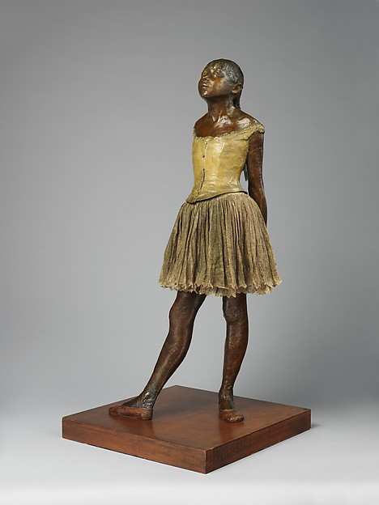

From here, walk into the adjacent gallery– Gallery 810 – where you will see early work by Eduard Manet, who you read about week #2 and who is considered the father of modern art. Notice the deep earth tones, browns and blacks of these early studio paintings before he began painting en plein air or outdoors with the Impressionists.
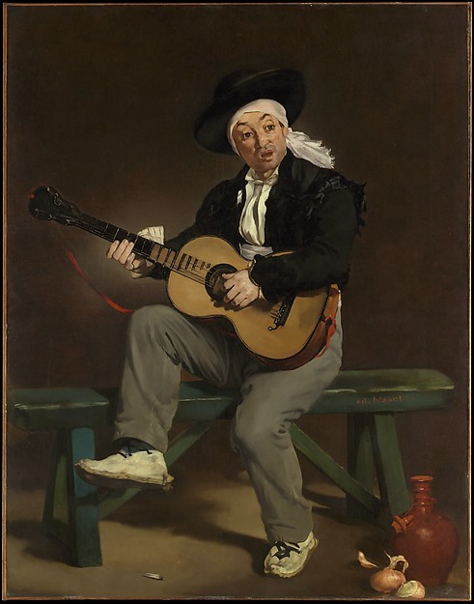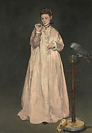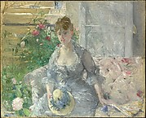
Walk through into gallery 821 and/or gallery 824 and look around both where you will see works by the Impressionists, including this Berthe Morisot painting (above right) and works by Auguste Renoir.
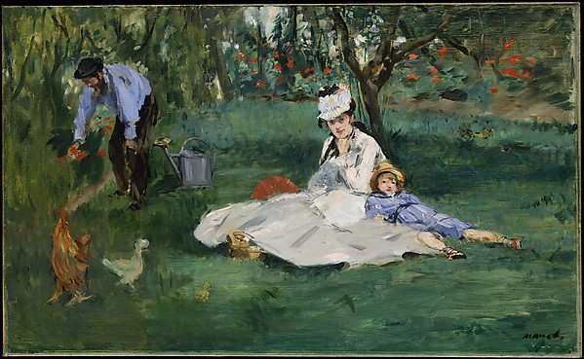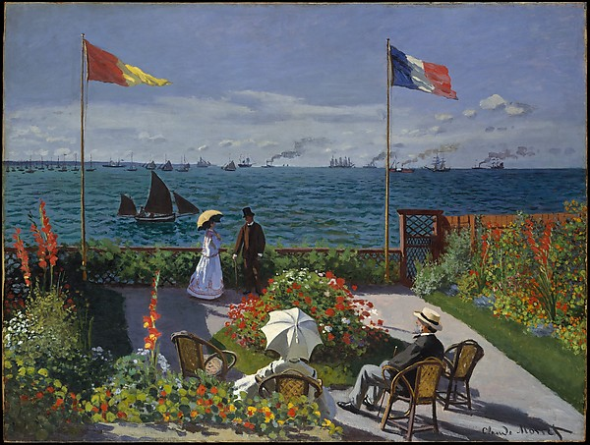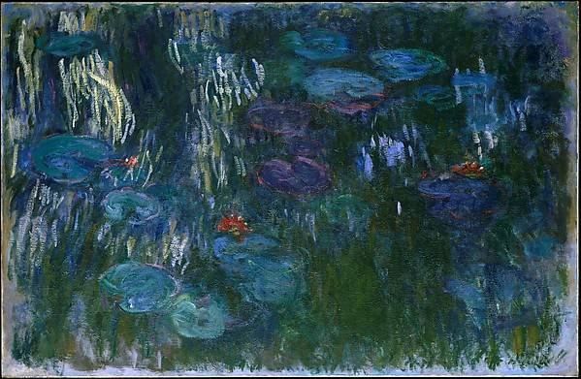
From Gallery 821 go into Gallery 818 where you will see one of the Monet’s discussed in class (thumbnail above in middle). Once Manet became friends with the Impressionists and they convinced him to begin painting outdoors, his palette changes dramatically. See two later paintings by Manet in this gallery, including the one above left where he painted Monet and Monet’s family in their garden.

These two adjacent galleries (818 / 819) are a great chance to see early Monet next to his later work. Over his lifetime, he stayed with one idea – the effects of light, color and atmospheric conditions on an object, but his style evolved dramatically over time, later favoring almost total abstractions in line and form to paint the lily pond in his garden.

Question #1: Impressionism (using these four galleries you have just visited 821, 824, 818 and 819 and gallery 820)

From these galleries, select one painting that best reflects the major ideas and characteristics of Impressionism in subject matter and formal characteristics.
You will now use this artwork to make an outline of Impressionism using complete sentences throughout.
Part 1: Introduce the artwork in a heading sentence in which you state the artist’s name, the painting’s title, its date, and a one sentence description of what the subject matter depicts (is it a landscape or an urban scene or a portrait). State this simply and directly.
Part 2: SUBJECT MATTER
Using numbered sentences (1, 2, 3,etc), state in one or two sentences each different element depicted in this painting that reflect an aspect of modern life at this time as discussed in any/all of the assigned essays, videos and in class. Why is this subject matter a reflection of modern life? List each element that is relevant.
Part 3: FORMAL CHARACTERISTICS
Using numbered sentences (1, 2, 3,etc), consider how the painting’s appearance and use of formal characteristics including types of line, forms, the organization of the composition, the color, and brushwork make it a good example of Impressionism as a style. Review the terms and concept document from week #1 if necessary. State how each element is treated in this artwork and what idea or relevant information about Impressionism this reflects.

Do not choose Monet’s Garden at Saint Adresse – pictured in the middle on page 2. This painting is off limits as we have discussed it in class.)

Question # 2: Post-Impressionism: (using these four galleries: 822, 825, 823, 826)

From Gallery 819, walk through the two galleries to the left and the two next to them (galleries 822, 825, 823, 826). You will recognize works by all of the 5 Post-Impressionists, including Seurat, Cezanne, Toulouse-Lautrec, Van Gogh and Gauguin. Walk around these galleries and examine works by these artists.

With Post-Impressionism, we see the beginning of abstraction take hold as artists begin to incorporate abstract color, specific types of lines and forms that do not appear realistic and spatial distortions to communicate their personal opinions, feelings or ideas in a subjective language, rather than with optically realistic or naturalistic images. Each of these artists had ideas and beliefs that were unique to them and had stylistic techniques and handling of the formal characteristics that were individual to them.

Question # 2: Select a painting by any of the Post-Impressionists except Seurat, who is off-limits here. Explain in your own words, how is this artwork a good representative example of the work of this artist? You are not writing their entire biography or life-story, but you are prioritizing what is most significant about them and finding the right artwork that illustrates this information.

The artwork should communicate information about the following: What is the artist’s overall goal or idea in selecting this subject matter and making this painting? What does it tell us about their beliefs or ideas? In terms of formal characteristics: what are they exploring and why is this important or interesting to them? How do they use the formal characteristics of color, line, form, and spatial organization to convey their feelings or ideas to the viewer? Be specific using as much of the artwork as possible to explain your content.

Directions to Question #3: Using European Sculpture Gallery 548
From these galleries, head into Gallery 830, where you will find artworks moving into the 20th Century by the Fauvists Henri Matisse and Andre Derain. You will also find works by Pablo Picasso in his transitional ‘rose period’ where he is beginning to simplify his figures into the geometric simplicity that will become Cubism.

From here, go right and into the corridor to find the bathrooms and the elevator. Take the elevator down to Floor 1 of the museum for Question #3. When you come out of the elevator, look to your left where you should see a Classical sculpture from the backside. Head towards it. This is the European Sculpture Gallery 548.

Examine this Classical sculpture by Canova of the ancient Greek hero Perseus. This is a great example of Neoclassicism, the style that took its inspiration from the idealized ancient Greek example and was dominant in the beginning of the 19th Century before modernism. The other works in this gallery are also Neoclassical or Romanticist in style by artists who came before Rodin and worked in traditional, academic styles during the first part of the 19th Century.

Next, find Auguste Rodin’s The Burghers of Calais sculpture closer to the windows overlooking Central Park. At the end of this explanation, I have included a short summary of what this sculpture is about. Review it so you understand why these people depicted by Rodin were going to be memorialized with a sculpture.

Rodin was a modernist in his approach to form. He was commissioned to make this historical monument by the French government. It caused a great controversy for several reasons:
1. Rodin has eliminated the use of a pedestal in his presentation of these figures (notice how all the other sculptures are on pedestals in this gallery).
2. He has not idealized the figures and instead, he has treated their forms in abstract, stylized, and expressionistic ways. This was unheard of at the time, especially for a historical monument! It was expected that a historical monument would use idealized, Classical forms.

Question #3: In two paragraphs, answer the following:
A. Explain the relationship between the figures in the sculpture and you as the viewer because of Rodin’s choice to eliminate the pedestal. What ideas or information about these historical figures is conveyed or communicated to the viewer with this choice in placement?
B. Rodin has used abstraction, stylization, and expressionistic elements to communicate the story of the Burghers’ ordeal as they may have experienced it.
Select two important elements of the sculpture’s appearance and explain what information Rodin communicates by using abstraction, stylization, and/or expressionism in these areas.
Consider, for example, what ideas are conveyed by the heaviness, verticality, and exaggeration of the drapery folds; the exaggerated size of the hands and feet; the varied arrangement of the figures in relation to one another; the texturized and bumpy surface appearance of areas of the figures; or other elements.
Do not just describe these things, but instead use their appearance as a way to explain what information is communicated using these representational choices.

(A note about color: The choice of bronze was a practical one with this sculpture intended for the outdoors. You are making an inaccurate assumption if you say that the dark color of this piece is symbolic or meaningful to the narrative. It’s not! Do not spend your answer discussing the color or choice of the bronze material. Instead, focus on what I am asking - what ideas or information is conveyed based on how Rodin has treated these forms.)

SUMMARY of the SUBJECT MATTER:

Auguste Rodin (French, born 1840 – died 1917), The Burghers of Calais, 1884–95, modeled or sculpted in clay, then cast in bronze (this version was cast in bronze in 1985)

The Burghers of Calais is probably the best and certainly the most successful of Rodin's public monuments. Rodin was commissioned by the city of Calais in northern France to commemorate an episode from the Hundred Years' War between England and France, which occurred during the Middle Ages in the 15th Century between 1337 until 1453.
Rodin closely followed the historical account of the French chronicler Jean Froissart stating that the six most prominent citizens of Calais, called Burghers at the time, were ordered to come out of their city, which had just been conquered by English forces, with their head and feet bare, ropes around their necks, and the keys for the gates to the city in their hands to surrender. They were being brought before the English king Edward III, who ordered the beheading of the six Burghers. In exchange for their sacrifice, he would spare the lives of the rest of the citizens of Calais. Rodin has portrayed them at the moment of departure from the city, led by Eustache de Saint-Pierre, the bearded man in the middle of the group. At his side, another Burgher, Jean d'Aire, carries a giant-sized key to the gates of the city. Their oversized feet are bare, many have ropes around their necks, and all are in various states of despair, expecting imminent death.
At this moment in the narrative, they are unaware that their lives will ultimately be saved by the intervention of the English queen Philippa. She was impressed by their sense of personal duty and sacrifice for the rest of the citizenry’s wellbeing so she successfully convinced her husband not to execute the Burghers.

This information is found on the Met’s website: http://www.metmuseum.org/toah/works-of-art/1989.407

