Met’s essay:
Two major influences on Cubism as developed by Pablo Picasso and George Braque are stated in the first paragraph – what are they:
1.

2.

What Picasso and Braque reject from tradition and what they wanted to emphasize instead are stated in paragraph 2. What are these things?

Rejected:

Emphasized:

What information from paragraph 2 relates to the appearance of this Cezanne image?
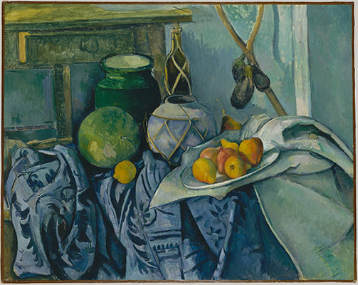 Still Life with a Ginger Jar and Eggplants

Paragraph 3 defines Analytic Cubism – what are the key aspects of it?

Paragraph 4 defines Synthetic Cubism – what are the key aspects of it?

What is a papiers collés?

In Cubism – Art History 101 Basics, three terms relating to Cezanne are used in the first paragraph: geometricity, simultaneity, and passage. Define each term in relation to an aspect of these artworks by Cezanne -where do we see geometricity, simultaneity, and passage in each of these? Is each of these three elements visible in each painting?
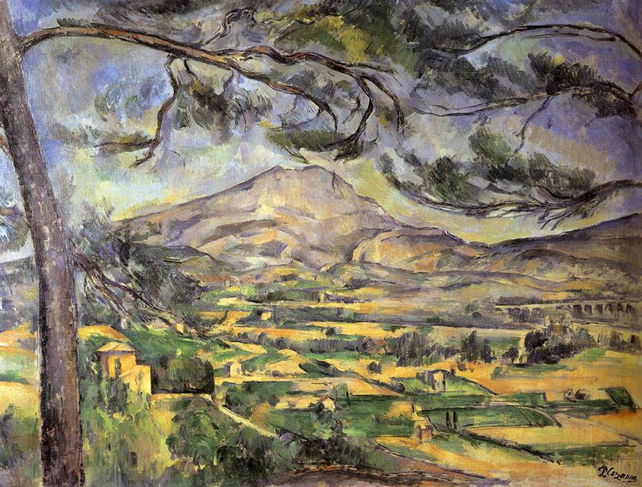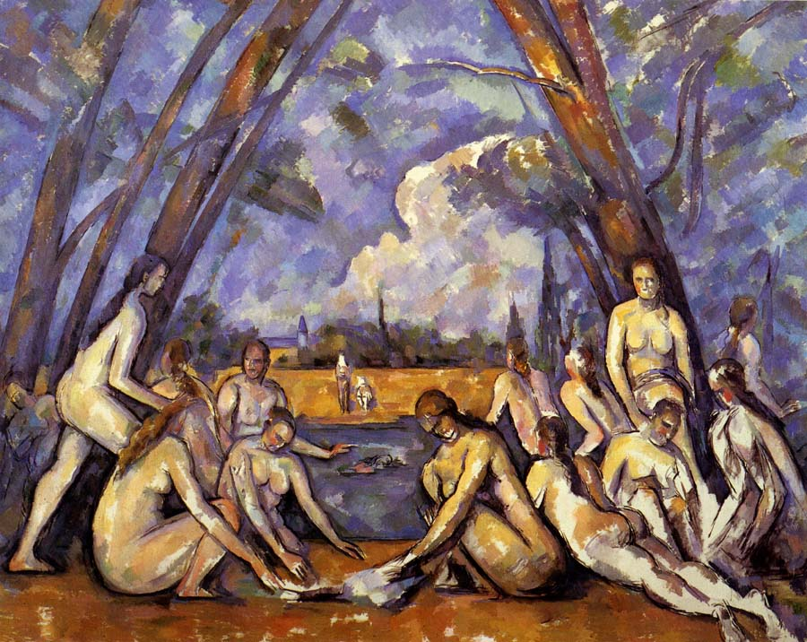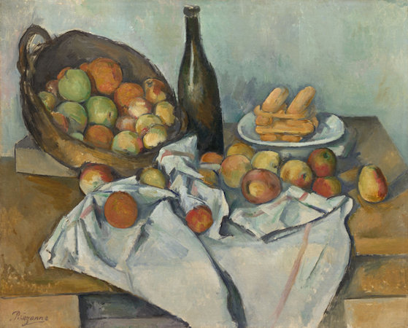
Cezanne, Mont Sainte-Victoire, 1885-87; The Large Bathers, 1906; and Still-Life with Basket of Apples, 1893

What do these terms mean: conceptual and perceptional?

Paragraph 3 takes you through the three terms above in relation to the featured artwork Still Life with Compote and Glass, 1914-15. Now, explain where we see each of these terms in the appearance of the painting mentioned later - Picasso's Les Demoiselles d'Avignon, 1907, which is in the collection of the MoMA.
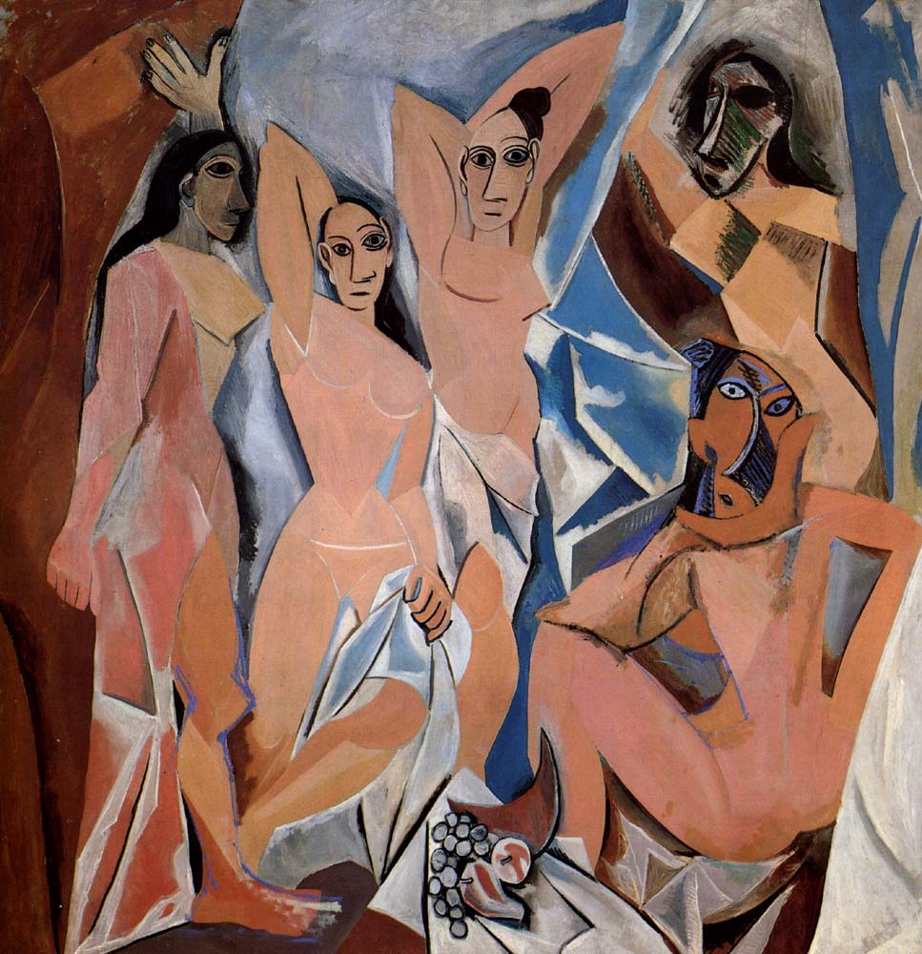
Where do we see geometricity?

Simultaneity?

and passage?

One of the 2 things introduced in paragraph 1 of the Met’s essay (see questions 1. & 2.) is also clearly visible here as an influence in the appearance of some of the figures.
(In the Khan Academy essay about Les Demoiselles d’Avignon, they also mention this source in relation to Portrait of Gertrude Stein.)
What source are they talking about? Explain what aspects of it are seen in Les Demoiselles d’Avignon:

In the essay about Picasso’s Portrait of Gertrude Stein, another visual source from ancient art is mentioned for Picasso’s treatment of her appearance. What is it? Look at the image used to illustrate this type of art in the essay. What aspects of its appearance correspond to the treatment of Stein’s face by Picasso?

In the ‘Inventing Cubism’ essay on Khan Academy, Braque’s painting Houses at L’Estaque is illustrated. Do we see geometricity, simultaneity, and passage in this work? How does he create visual depth here?
Geometricity – if so, where?

Simultaneity – if so, where?

Passage – if so, where?

How does he create visual depth here?

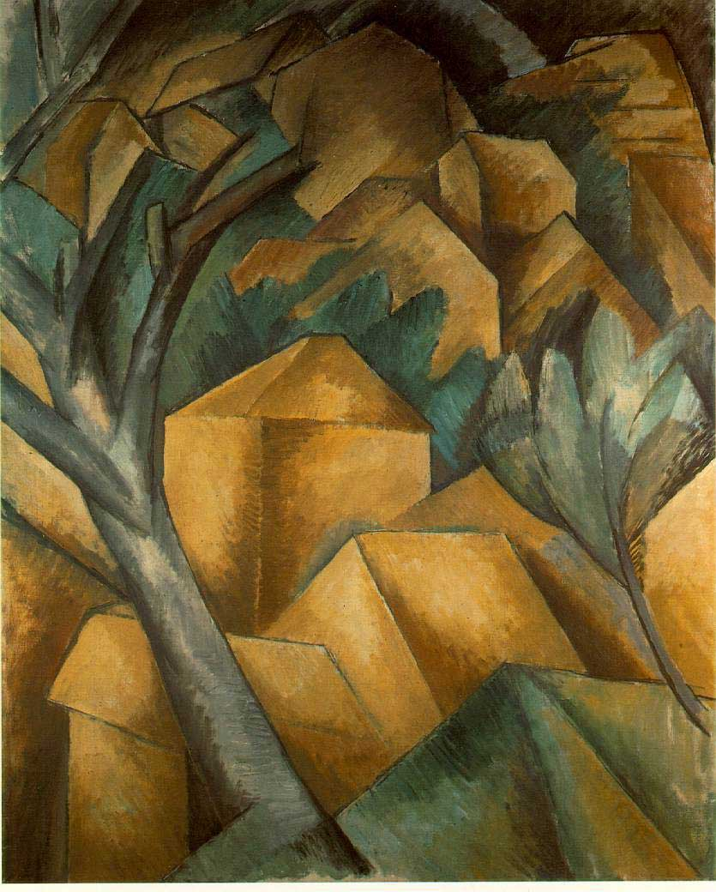

After reading about the collage Still-Life with Chair Caning, explain two expectations or ideas about an artwork that this and other Synthetic Cubist collages contradicts, undermines or challenges?

1.

2.

